**CIRCUIT:**

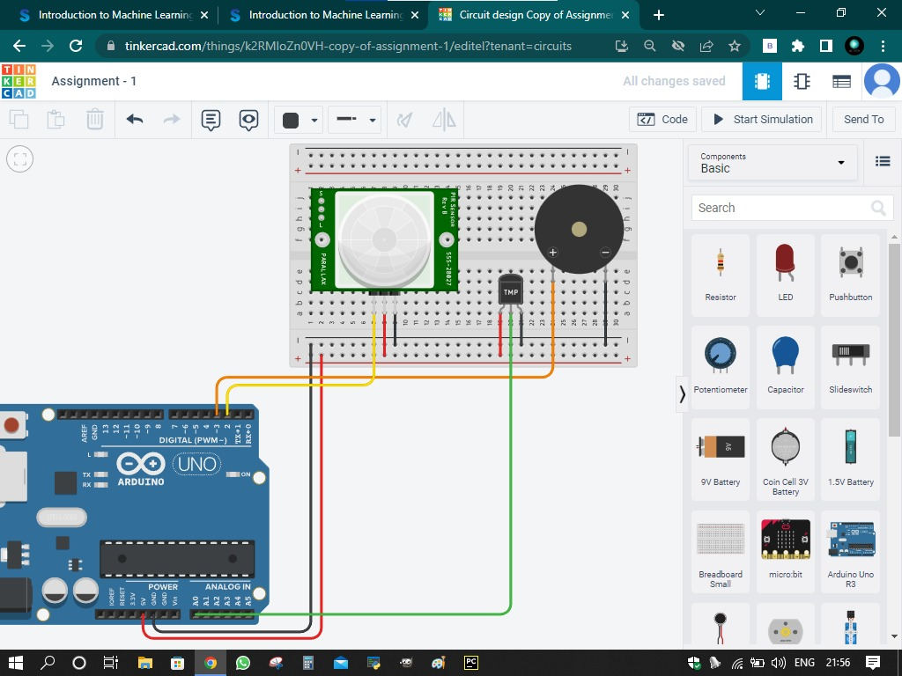

**CHANGING TEMPERATURE:**

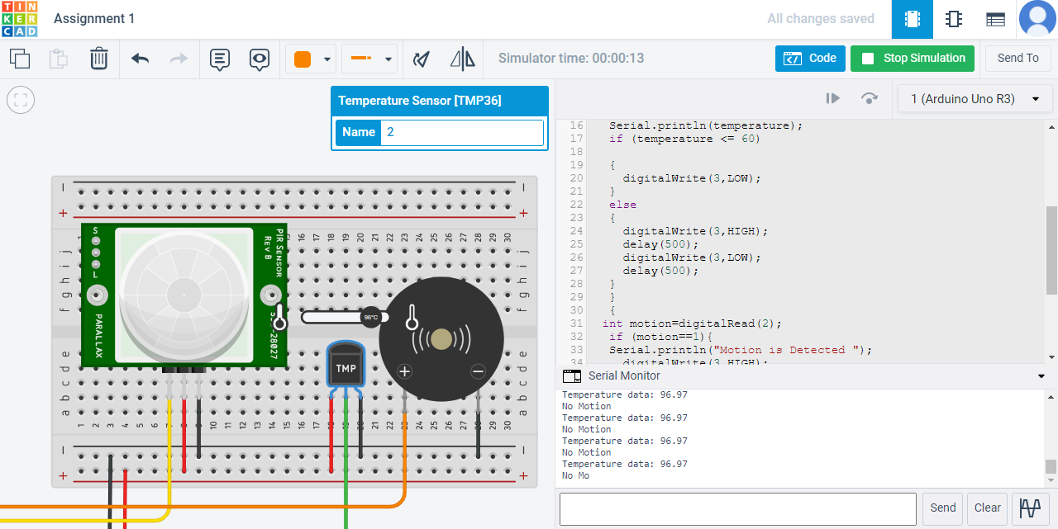

**CHANGING POSITION IN PIR SENSOR:**

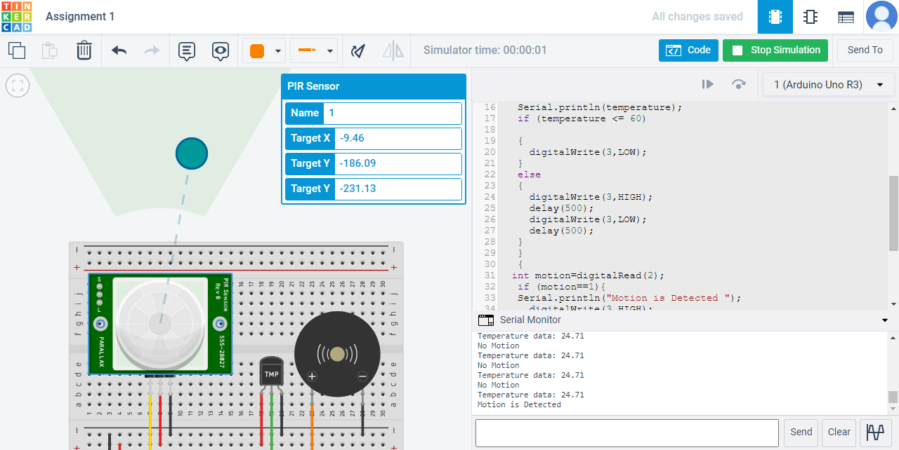

**PROGRAM:**

void setup()

{

Serial.begin(9600);

pinMode(3,OUTPUT);

pinMode(2,INPUT);

}

void loop()

{

{

double data=analogRead(A0);

double n=data/1024;

double volt=n*5;

double off=volt-0.5;

double temperature=off*100;

Serial.print("Temperature data: ");

Serial.println(temperature);

if (temperature <= 60)

{

digitalWrite(3,LOW);

}

else

{

digitalWrite(3,HIGH);

delay(500);

digitalWrite(3,LOW);

delay(500);

}

}

{

int motion=digitalRead(2);

if (motion==1){

Serial.println("Motion is Detected ");

digitalWrite(3,HIGH);

delay(5000);

digitalWrite(3,LOW);

delay(500);

}

else{

Serial.println("No Motion");

digitalWrite(3,LOW);

}

}

}